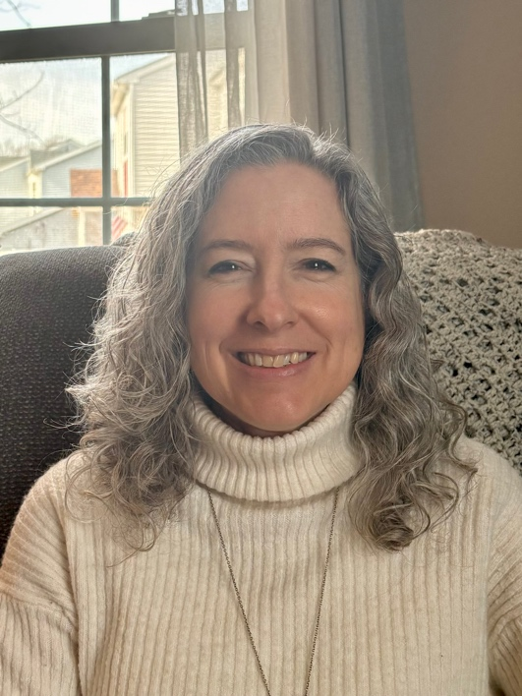**Retreat Leader Bio**

# **Spiritual Director Retreat Leader Artist**

* **Spiritual Direction**

Companion another in the spiritual journey through prayerful listening

* **Group Spiritual Direction**

Facilitate group spiritual direction

* **Shepherds Gathering**

A monthly invitation for shepherds to gather to listen for God

* **Retreats**

One day and three-day retreats for attending to God

* **Artwork**

Prints & greeting cards - images reflecting our walk with God

* **Books**

*Journey to Become, Divine Hands, and Encounter*

Full color devotional and journal woven together with artwork, reflections, and Scriptures

* **Personal Retreat Guide**

*Come*

Black and white retreat workbook

**space.to.listen@gmail.com**

**creatingspacetolisten.com**

**Christine Labrum**

*“Creating Space to Listen”*

Christine Labrum is a spiritual director, retreat leader, and artist. Her vocation is to companion and shepherd others with presence, words, and art. Christine’s journey with God has led her down a meandering road of diverse experiences, a decade of singleness, and over twenty years of marriage and motherhood with a mug of coffee in her hand at every turn (in fact, she has an eclectic collection of pottery mugs that she loves to fill with coffee and share!).

Christine is passionate for us to experience God’s intense pursuit of our hearts: God’s kind invitation to repentance, God’s offer of deep rest from our striving, and God’s gift of love that leads us toward renewal, transformation, and co-creation. Her desire is to live life with God in an ever deepening surrender, intimacy, and partnership. She is committed to engaging, encouraging, and teaching spiritual practices (disciplines) that enable us to open our hearts and minds to God’s Spirit through Jesus, our Lord and Savior. As a spiritual director, retreat leader, and group leader she facilitates creating and holding space in our lives with intention to engage with God and listen to His voice.

Christine graduated from Messiah College with a Bachelor of Arts in studio art in 1992. She also earned a Master of Divinity from Biblical Seminary in 2004 and completed spiritual direction training at Kairos: School of Spiritual Formation in 2013.

*After you have suffered for a little while, the God of all grace, who called you to His eternal glory in Christ, will Himself perfect, confirm, strengthen and establish you. To Him be dominion forever and ever. Amen.*

*1 Peter 5:10-11NAS*